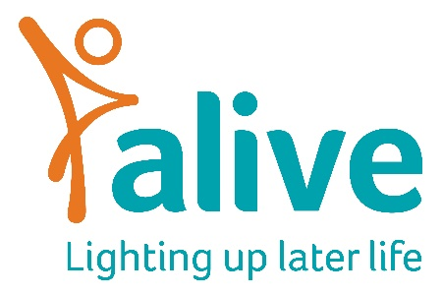

Job Description
Position: One Good Turn Project Officer (0.4 FTE) (Maternity Cover) 2 days a week, up to 8 months contract – December 2021 to July 2022.
Reports to: Community and Technology Projects Manager (TBC)
Salary: Up to £25,000, dependent on experience
Overall Job Purpose:
- To continue, coordinate and close Alive’s ‘One Good Turn Project’ Funded by Sovereign Housing. More information on the project can be found here.
- To set up ‘One Good Turn’ Community development initiatives. Encouraging intergenerational social action projects across Bristol. Working primarily with Sovereign residents.
- To develop Alive’s intergenerational work in the Bristol area

Main duties and responsibilities:
- Develop Alive’s One Good Turn Project and understand how it can be run in the community, not just in care homes.
- Set priorities for the project and recruit suitable project participants and community groups.
- Plan social action initiatives with Sovereign residents and children.
- Keep an open dialogue with participants to enable them to choose and shape the content of their activity sessions
- Produce regular project newsletters to keep Sovereign residents up to date with project activities.
- Hold regular project management meetings with relevant staff and external partners and produce progress reports as required
- Develop any promotional material required for the projects
- Monitor and evaluate the sessions using the ArtsObs evaluation tool and share our learning throughout the adult care sector, where appropriate
- Utilise relevant performance and evaluation tools to monitor, measure and report on the impact of the projects
- Manage the project budget, keeping accurate records of expenditure
- Work with the Marketing Manager to develop marketing and social media content
- Make recommendations on lessons learned from pilots and on how successful projects can be extended or turned into regular services

Person specification:

Experience

Essential:
- Developing, managing and coordinating projects successfully
- Understanding the principles and practices of providing person-centred, co-produced and accessible services
- Working with any one or more of the following groups/settings: children, older people, schools or care homes
- Producing appealing promotional communications

Desirable:
- Working in the voluntary sector in either a projects, services, marketing or business development role
Skills and Knowledge:

Essential:
- Skills in facilitating groups, ensuring every member has the chance to be involved
- Great relationship builder with strong inter-personal skills
- Excellent record-keeping and budget management skills
- Ability to establish good working relationships with staff, management, volunteers, family members and local communities
- Ability to multi-task, prioritise and take the initiative to solve problems
- Strong organisational skills, with attention to detail
- Ability to work independently, proactively and under own initiative
- Excellent written and verbal communication skills and phone manner
- Computer literate and familiar with using common Office (365) programmes

Desirable:
- Educated to degree level or equivalent experience

Project management qualification or course attendance
- Able to update wordpress websites
- Able to use the Adobe suite to produce printed documents

Personal attributes

Essential:
- A self-starter, able to work independently, on their own initiative, and as part of a team
- Organised and able to multi-task in a busy open plan office
- Creative thinker who can develop new ideas and turn them into action
- Passionate about improving the lives of vulnerable older people
- Flexible and adaptable
- Positive and enthusiastic outlook
- Friendly and approachable team player
- Ability to create a warm, safe, welcoming environment and foster positive relationships for older and young people alike

Other requirements
Essential:
- Willingness to travel across the area covered by the projects

Desirable
- Portable online DBS (enhanced disclosure)

Terms and Conditions of employment

Salary: Up to £25,000 p.a. pro rata depending on experience, plus pension. Salaries are paid monthly in arrears and reviewed annually.

Conditions of employment: The post if for 2 days a week, starting in December and will be to cover a maternity leave post for 7 months. We work a 7.5-hour day. Annual holiday allowance is 25 days plus Bank Holidays pro rata. Holidays to be taken during local authority school holidays and not in term time due to the nature of the work delivered.

Location: Alive is based at the Create Centre, Smeaton Road, Bristol BS1 6XN.

Training: You will be encouraged to attend Alive sessions on a regular basis in order to understand and communicate what we do more effectively.
Please note: This job description is for guidance. Employees are expected to be flexible and co-operative and to undertake additional duties as required.

