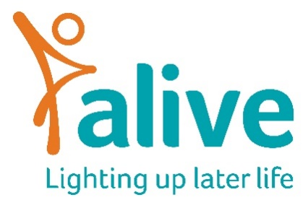

Job Description

Position: Wishing Washing Line Project Manager (0.6 FTE) 22.5 hours a week, 12 month contract
Reports to: Community Projects and Technology Manager

Overall Job Purpose:

This is a fantastic opportunity to run an incredibly rewarding project. The Wishing Washing Line is an initiative the aims to encourage members of the public to grant wishes for older people living in care homes.

Wishes as small as a chat and a cup of tea and as big as flying lessons have been granted. The project ran in both Bristol and Exeter before the pandemic and funding has been secured to continue the project starting in early 2022.

To see the project in action, visit our facebook page

Main tasks and responsibilities
Running the Wishing Washing line
- Collecting wishes from older people living in care homes
- Working to promote these wishes to the community
- Monitoring if and when wishes are granted
- Evaluating the impact of the line
- Monitoring the growth of other Wishing Washing Lines Nationwide
- Supporting ‘headline wishes’ to be granted to gain publicity for the project
- Working with the wider Alive team to feedback on the older people’s wishes to help support the delivery of wider services.

Supporting the growth of the wishing washing line nationwide
- The Wishing Washing Line has previously been run as a franchise, with other charitable organisations running their own lines. Part of the role will be to support these other organisations in setting up and running these.
Promoting the profile of the Wishing Washing Line
- The wishing Washing Line has seen great success with viral videos and many TV appearances. A large part of your role will be PR and social media focussed, promoting when wishes are granted.

Person Specification

Experience/Knowledge
Essential:
- A good understanding of the needs and issues for older people, people with dementia and care home staff
- Experience of developing and maintaining good working relationships with staff and management of partner organisations
- Experience of working with and supporting volunteers
- Experience in using social media to promote projects or products
- Experience in writing press releases and publicising opportunities to the press
- Experience in co ordinating events or TV production work.
- Experience of delivering on administrative tasks professionally, competently and on time
- Knowledge of project evaluation

Desirable:
- Experience of working in the care sector or with people with health and social care needs
- Experience of caring for someone with health and social care needs and or of supporting unpaid family carers
- Knowledge of co production and/or public consultation

Skills
Essential
- Excellent verbal and written communication skills
- Confident using social media tools
- Organisational and administrative skills
- Good networking skills
- Excellent record-keeping skills
- Computer literate, including using Office (365) suite

Desirable
- Adept at creating posters, flyers and newsletters, using the Adobe Creative Suite

Attributes
Essential
- Ability to establish good working relationships with staff, management and volunteers
- Ability to work independently, proactively and under own initiative
- Friendly and approachable
- Confident and assertive
- Creative and able to think differently
- Ability to be flexible and make the best use of available resources
- Ability to manage time effectively
- Commitment to equal opportunities in practice

Terms and Conditions of employment

Salary: £25,000 p.a. (pro rata) plus, contributory pension. Salaries are paid monthly in arrears and reviewed annually.

Conditions of employment: This post is for 3 days a week (0.6) – 22.5 hours a week. Days to be agreed on appointment of the suitable candidate. Hours can be worked flexibly provided they are between Alive’s core working hours of 9 – 5. Alive staff work a 7.5-hour day. Annual holiday allowance is 25 days (pro rata) plus Bank Holidays. This is for a 12 month contact.

Location: Alive is based at the Create Centre, Smeaton Road, Bristol BS1 6XN.

Training: You will be encouraged to attend some Alive sessions and training, etc, in order to be able to communicate what we do to our clients.
Please note: This job description is for guidance. Employees are expected to be flexible and co-operative and to undertake additional duties as required.

