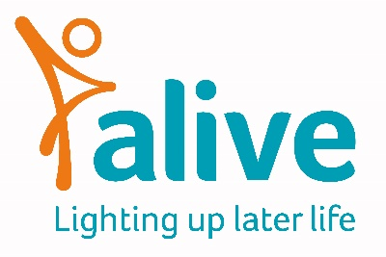

Job Title: Dementia Meeting Centre Activity Worker

Salary: £10.20 an hour
Post: 3 days a week, 6 hours a day, 18 hours a week. 12-month initial contract

Overall Job Purpose:
To work with people with dementia and their carers to engage in meaningful activities at three Meeting Centres held in Clevedon, Portishead and Nailsea.
To work as part of a staff team and alongside volunteers and members.

Main tasks and responsibilities
- Setting up the venues for Meeting Centres, preparing activities with members and clearing the venue at the end of the session
- Providing a friendly and safe atmosphere by encouraging and helping members to get involved in recreational and social activities
- Offering meaningful activities in response to members’ life experiences, history, interests and abilities
- Developing and carrying out one to one and group activities, using dementia-friendly techniques, materials and IT resources
- Developing and updating a support plan with individual members
- Working with members to evaluate progress towards goals agreed in their support plan, and informing the Meeting Centre Manager
- Running activities and responding to the needs and requests of members
- Assisting in tasks such as making drinks, meals and washing dishes
- Advising members on other support services as appropriate
- Attending daily briefings with the Meeting Centre Manager
- Participating in the monthly Meeting Centre meeting
- Contributing to the evaluation of the Meeting Centre project
- Carrying out any related administrative and financial activities.

Additional responsibilities:
- To comply with data protection regulations, ensuring that information about members remains confidential
- To be responsible for learning and development for yourself
- To support community fundraising and media events
- To work within safeguarding and confidentiality policies

Person Specification

Skills
- Confident in working with people with dementia and their carers
- Able to working with groups and individuals in a person centred way
- A good understanding of safeguarding and confidentiality policies
- Organised and can carry out basic administrative tasks
- Good record-keeping skills
- Computer literate, including using Office Word (365)

Experience
- Experience of working with people with dementia
- Experience of running group and individual activity sessions with people with dementia
- Experience of working in a team

Attributes
- A real people person
- A great communicator, especially with people living with dementia
- Able to create a warm and friendly atmosphere
- Empathy and compassion
- Good team player
- Ability to establish good working relationships with staff, members, other services and volunteers
- Ability to work independently and under own initiative
- Able to travel independently within the three meeting centre areas
- Ability to be flexible and make the best use of available resources

Terms and Conditions of employment

Salary: £10.20 an hour plus contributory pension. Salaries are paid monthly in arrears and reviewed annually.

Closing date: Applications using the Alive application form by 9 am Monday 6th June and interviews will be held on Wednesday 8th June. Please email applications to louise@aliveactivites.org

Conditions of employment: This post is for 3 days a week, 6 hours each day across Tuesday, Wednesday and Thursday each week as dictated by venue availability. Annual holiday allowance is 25 days (pro rata) plus Bank Holidays. This is a 12-month contact.

Location: You will work remotely at the Meeting Centre venues.

Training: You will be encouraged to attend some Alive sessions and training. You will also attend the Meeting Centre UK Support Group and attend any training run by the national body.
Please note: This job description is for guidance. Employees are expected to be flexible and co-operative and to undertake additional duties as required.

