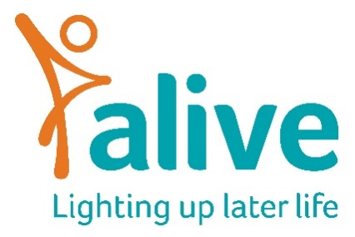

Job Description

Position: Volunteer Coordinator
Hours: 0.4 FTE – 15 hours per week
Contract: 12-month fixed term contract
Salary: £
Reports to: Community Services Manager

About the Role
Alive is looking for a warm, organised and proactive Volunteer Coordinator to support and develop our volunteer community. Volunteers play a vital role in helping older people and people living with dementia take part in meaningful, creative and relationship-centred activities. This role will help ensure volunteers feel welcomed, valued, supported and connected to Alive’s mission and values.
The Volunteer Coordinator will lead on volunteer recruitment, onboarding, coordination and communication, helping to create a positive and inclusive volunteer experience across Alive’s services.

Main Responsibilities
1. Volunteer Recruitment and Onboarding
- Coordinate volunteer recruitment activities, including responding to enquiries and promoting opportunities through volunteer platforms, social media and community networks
- Organise and support safer recruitment processes, including applications, references and DBS checks
- Arrange and support volunteer interviews and induction sessions
- Ensure new volunteers receive the information, training and support needed to feel confident in their role
- Work with Alive staff to match volunteers to suitable sessions and opportunities

2. Volunteer Coordination and Support
- Work with Alive staff to coordinate volunteer rotas
- Maintain regular communication with volunteers, staff and facilitators
- Help ensure volunteer support is available across Alive Clubs, gardening sessions and Meeting Centres wherever possible
- Build positive relationships with volunteers, helping them feel connected, appreciated and part of the Alive team
- Organise volunteer meetings, updates and recognition activities, including thank-you communications and volunteer newsletters
- Support volunteers with expenses claims and general enquiries
- Identify opportunities for volunteers to represent and promote Alive within the community

3. Volunteer Systems and Administration
- Maintain accurate volunteer records, databases and recruitment documentation
- Keep volunteer policies, procedures and handbook materials up to date
- Support the coordination of volunteer training and ongoing learning opportunities
- Liaise with Alive staff and external partners to support effective volunteer involvement across services
- Report any safeguarding concerns, incidents or significant volunteer issues to the appropriate manager

This role description is not exhaustive and may develop over time in line with the needs of Alive and the people we support.

Appointment to this post is subject to satisfactory references and an enhanced DBS check.

Person Specification

Experience and Knowledge
Essential
- Understanding of the needs of older people, people living with dementia and care home staff
- Experience of working with and supporting volunteers
- Experience of volunteer recruitment, coordination or administration
- Experience of building positive working relationships with colleagues, volunteers or partner organisations
- Good organisational and administrative experience, with the ability to manage competing priorities
Desirable
- Experience of working in health, social care or community settings
- Experience supporting unpaid carers or people with additional support needs
- Knowledge or interest in gardening, nature-based activities or creative community work

Skills and Attributes
Essential
- Strong verbal and written communication skills
- Good organisational and time management skills
- Ability to work independently and use initiative
- Friendly, approachable and relationship-focused
- Confident using Microsoft Office and online systems
- Commitment to equality, inclusion and person-centred practice
- Ability to work flexibly and collaboratively as part of a small team
Desirable
- Experience creating newsletters, posters or social media content
- Confidence using volunteer management systems or databases

Terms and Conditions
- Salary
£28,500 per annum FTE, plus contributory pension. Salary is paid monthly in arrears and reviewed annually.
- Hours
15 hours per week (0.4 FTE), usually worked across 2 days or flexibly across the week by agreement. Working hours should normally fall within Alive’s core hours of 9am–5pm.
- Contract
12-month fixed term contract.
- Annual Leave
25 days annual leave pro rata, plus Bank Holidays.
- Location
Alive has a storage and meeting room facilities at the Create Centre, Smeaton Road, Bristol BS1 6XN however staff currently work in a remote way.
- Training
The successful candidate will be encouraged to attend Alive sessions and training to develop understanding of our work and values.

